To my dear students,

First of all, I hope you and your families are ok. I know these are difficult times, but I am sure that we will get over this situation soon. Try to spend more quality time with your family. Nowadays, is not as easy as it should.
Homework: During the quarantine we are going to revise most of the units we have done during the whole school year. I’ll try to select activities that can be done at home and those that don’t need special materials.
We are going to star with Yoga. It will help you to relax and it also gives you the chance to improve your flexibility and strength. You already know the sheet that is in this document, but instead of doing the test you will have to do something different with the “Asanas”.
Choose 15 asanas from the form and practice them. Using the same 15 asanas try to perform all of them linked, the same as in a Sun Salutation but invented by you. Do a video (not longer than one minute) or a pictures montage. If you don’t want to appear in the pictures, cover your face or take the pictures from your back. Please, try to choose the lowest resolution of the pictures, otherwise you won’t have space enough to send the pictures in only one email. You can also do asanas in couples that are also included in this document.
Dead line: send it to my email address: vanessadg@educastur.org until April 24th. Once I receive your videos and pictures, I will send you an email to let you know that I have received your project. If you don’t receive any confirmation in two days, please write to me again to make sure I have received your first email.
Remember that is very important keeping physically active during the quarantine. There are countless mobile applications that mark you the exercises to be performed and even in rhythm. One of them is called Sworkit, you already know it. Some of you have already sent to me some pictures working out and even very cool videos. If you have any formula to keep fit these days and you want to tell me or send a photo of it, go ahead! Surely, they are very original ideas!
If you have any question, let me know
Send you a warm hug and best wishes for you and your family
Vanessa de Dios
ASANAS
 |  |  | 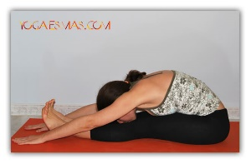 | 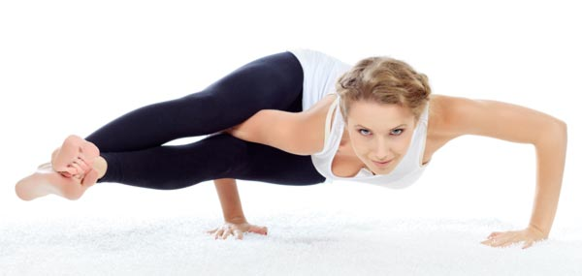 | 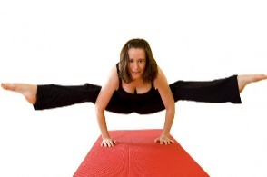 | 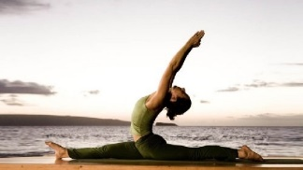
 |  |  |  |  |  | 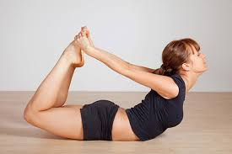
 | 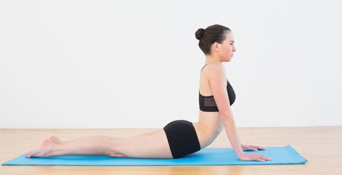 |  |  |  |  | 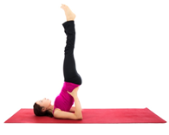
 |  | 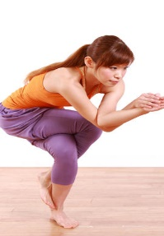 |  | 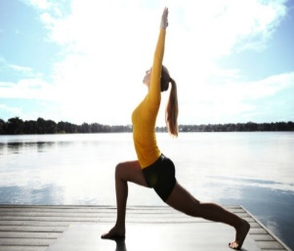 |  | 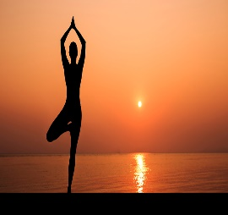
 |  | 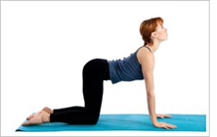 |  | 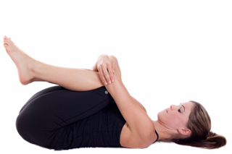

ASANAS IN COUPLES
